Teacher Notes for “Stability and Change in Biological Communities”

This analysis and discussion activity engages students in understanding how biological communities remain stable and how they change during ecological succession. Students analyze several types of research evidence, including (1) repeated observations of a biological community to assess stability or change over time, (2) analyses of dated fossils in a peat bog, and (3) analyses of how mutualism, competition and trophic relationships contribute to stability or change in biological communities. Students use this evidence to understand the causes of stability and succession in a variety of habitats, including a tropical forest, a new volcanic island, abandoned farm fields, and ponds. Students also analyze the effects of climate and non-native invasive plants.

I estimate that this activity will require roughly 2 50-minute periods.

The PowerPoint available at https://serendipstudio.org/exchange/bioactivities/succession has color pictures that illustrate the biological communities in this activity. These Teacher Notes suggest when to show various slides.

Learning Goals
In accord with the Next Generation Science Standards:
- This activity will help students to meet the Performance Expectation:
HS-LS2-6. "Evaluate the claims, evidence and reasoning that the complex interactions in ecosystems maintain relatively consistent numbers and types of organisms in stable conditions, but changing conditions may result in a new ecosystem."
- This activity helps students to understand the Disciplinary Core Idea, LS2.C, Ecosystem Dynamics, Functioning and Resilience:
“A complex set of interactions within an ecosystem can keep its numbers and types of organisms relatively constant over long periods of time under stable conditions. If a modest biological or physical disturbance to an ecosystem occurs, it may return to its more or less original state (i.e. the ecosystem is resilient), as opposed to becoming a very different ecosystem. Extreme fluctuations in conditions or the size of any population, however, can challenge the functioning of ecosystems in terms of resources and habitat availability. Moreover, anthropogenic changes (induced by human activity) in the environment – including habitat destruction, pollution, introduction of invasive species, overexploitation, and climate change – can disrupt an ecosystem and threaten the survival of some species."
- In this activity students engage in these Science and Engineering Practices:
  - “Constructing Explanations: Apply scientific ideas, principles, and/or evidence to provide an explanation of phenomena…”
  - “Engaging In Argument from Evidence: Make and defend a claim based on evidence about the natural world….”
- This activity will provide the opportunity to reinforce two Crosscutting Concepts:
  - “Stability and Change: Much of science deals with constructing explanations of how things change and how they remain stable.”
  - “Scale, Proportion, and Quantity: Patterns observable at one scale may not be observable or exist at other scales. Some systems can only be studied indirectly as they are… too slow to observe directly.”
- This activity can be used to reinforce student understanding about the Nature of Science.
- "Science investigations use diverse methods and do not always use the same set of procedures to obtain data.”
- “Science knowledge is based on empirical evidence."

Instructional Suggestions and Background Information
To maximize student participation and learning, I suggest that you have your students work individually, in pairs, or in small groups to answer a question or small group of related questions; then, after each question or group of questions, have a class discussion of student answers to probe their thinking and guide them to a sound understanding of the concepts and information before moving on to the next section. You may want to try having your students work in groups of four, each with a specific task. One student is the facilitator (responsible for keeping the group on task and time management). Another student is the reader (reads information out loud). Another student is the recorder (records the answers in the Student Handout that the group turns in). The fourth student in each group is the spokesperson (reports out to the class during class discussions).

A key is available upon request to the author (iwaldron@upenn.edu). The following sections provide additional background information and instructional suggestions.

As you discuss student answers to question 1, it will probably be helpful to clarify that this activity will not consider housing or commercial development or seasonal changes, both of which are probably more familiar to students than the long-term changes in biological communities that are discussed here.

Stability in a Hawaiian Tropical Forest
In this section, students analyze how mutualisms maintain the tropical forest in a stable state. This tropical forest can be considered a climax community, since it is relatively stable. However, small changes occur, e.g., when a canopy tree dies and lets in more sunlight. I recommend that you show slides 2-5 before question 2; these slides (available at https://serendipstudio.org/exchange/bioactivities/succession) show this tropical forest, including the moss and a fruit-eating Hawaiian bird (the omao). You can ask your students how they think the different organisms shown interact with each other.

Life Comes to a New Volcanic Island
Surtsey Island arose through volcanic activity in the mid-1960s. Slides 6-7 illustrate the volcanic eruptions that produced Surtsey. You might also want to show your students the 1.7-minute video, “Volcanic Activity: The Formation of Surtsey" (https://www.britannica.com/place/Surtsey). Understanding the volcanic origin of Surtsey Island will help students understand why Surtsey began with no life on it. Even before the end of the volcanic eruptions that formed Surtsey, Iceland restricted human exploration to scientists who studied the development of biological communities on the bare rock of Surtsey Island. Surtsey is only 5 km from the nearest small island and only 32 km from Iceland, which facilitated the development of biological communities on Surtsey. By 2012, erosion had reduced the area of Surtsey Island to only 1.3 km².

Question 4 is designed to get students thinking about the driving question for this section. You can show slides 8-11 as students are answering question 4 to help them come up with ideas about how life got started on Surtsey.

The feces of the gulls in the breeding colony brought seeds and fertilizer, including nitrogen and other minerals, which fostered plant growth. Dead plants and birds provide food for invertebrates, including insects, mites and springtails that feed on decaying organic matter. These small invertebrates arrived by wind (especially flying insects), by sea (especially on floating objects carried by sea currents), and by birds (e.g., carried on nesting material from outside Surtsey). Facilitation occurs when earlier species in succession change the environment in ways that help later species in succession become established. After question 5, I suggest that you point out how the gulls changed the environment in ways that allowed plants to grow. This general idea will be revisited in question 7b, 17 and 20a.

Outside the gull colony, other biological communities have also developed, including the lichens and mosses that cover much of the island. Lichens are common pioneer species in primary succession (succession where soil is absent) (shown in slide 11 and the interactive recommended near the bottom of page 2 of the Student Handout). For the interactive about primary succession, I recommend that you have students work in small groups and take turns reading the information in the labels (before moving on to clicking). This interactive has a lot of information and is engaging, but it is somewhat misleading. For example, near the beginning it says that “Each organism has different requirements for survival. For this reason, succession is an orderly process.” However, as discussed in a later section (questions 11-13), succession can vary due to both systematic and chance factors. In the interactive, the forest is described as a climax community, which will be stable for a long time. As discussed in the next section, succession does not always culminate in forests. Although Iceland has some forests, the small islands near Surtsey Island have grasslands, but no forests. Also, change is observed in climax forests (question 14 in the next section). You may need to remind your students about the distinctions between primary, secondary and tertiary consumers, and you may want to use either of our food web activities (https://serendipstudio.org/sci_edu/waldron/#ecolfoodweb or https://serendipstudio.org/sci_edu/waldron/#foodweb) to clarify that in real biological communities most secondary and tertiary consumers are actually trophic omnivores (an animal that eats organisms from more than one trophic level).

Lichen are mutualistic symbioses between fungi and photosynthesizing algae (or cyanobacteria) (see possible additional question and figure below). The photosynthesizing algae produce organic compounds which feed both the algae and fungi. The fungi attach to the rock and retain moisture which helps both the fungi and the algae. The fungi secrete acid that breaks down the volcanic rock; this, together with decaying organic matter, begins the process of soil formation. Some mosses can grow on bare rock and some mosses will grow on the soil created by lichen. Eventually, as the lichens and mosses create more soil, other plants can grow. This type of succession can take centuries to reach a climax community.

You may want to add this question at the beginning of question 7 in the Student Handout.

7a. Lichens are a mutualistic symbiosis between algae and fungi. Symbiosis means living together and refers to a long-term close physical relationship. Fill in the boxes to explain why the symbiosis in lichens is mutualistic.

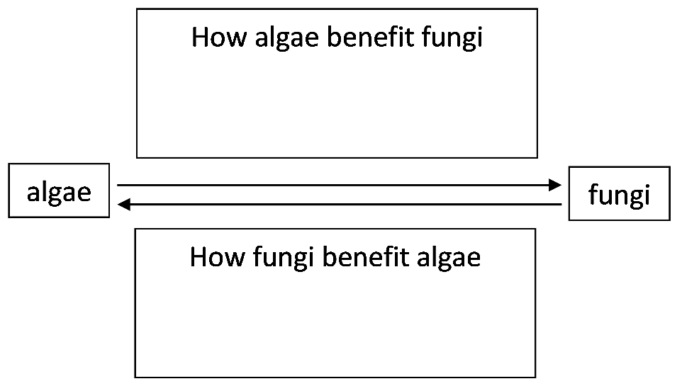

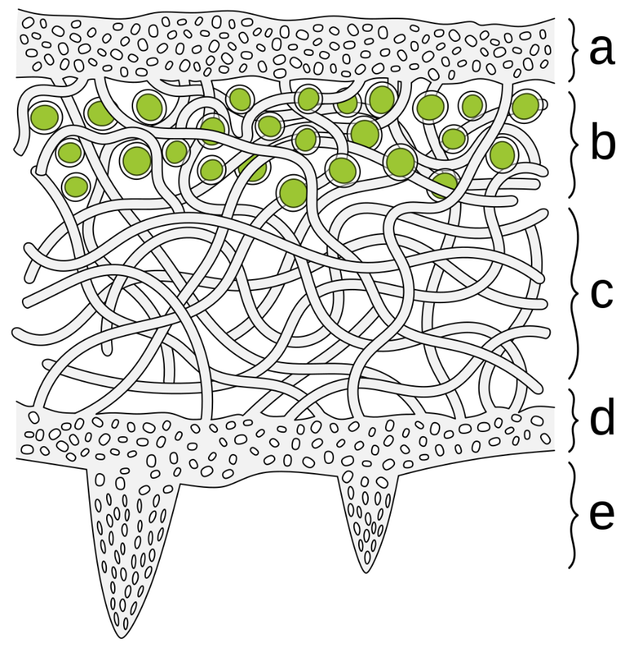  (https://en.wikipedia.org/wiki/Outline_of_lichens#/media/File:Lichen_cross_section_%E2%80%93_heteromeric_thallus.svg) | Structure of a Lichen  (a) outer layer of tightly woven fungus filaments (hyphae)  (b) layer of photosynthesizing algae  (c) loosely packed fungal hyphae  (d) inner layer of tightly woven layer of fungal hyphae  (e) anchoring hyphae called rhizines where the fungus attaches to the substrate
Changing Biological Communities in Abandoned Farm Fields
I recommend that you show slides 12-14 at the beginning of this section. This type of succession has been observed in abandoned farm fields in temperate areas with sufficient rainfall in North America, Europe and Japan.

In the early stages of succession after an agricultural field has been abandoned, the biological community consists primarily of plants that (1) have seeds that disperse readily over substantial distances and (2) grow and reproduce rapidly. Herbaceous plants that thrive in full sun and tolerate relatively dry conditions tend to be more abundant early in succession, whereas herbaceous plants that tolerate partial shade and prefer moister soil are generally more abundant later in succession.

In the later stages of succession in abandoned farm fields, long-lived plants that are good competitors for light and water become more conspicuous and abundant. Often a forest develops if there is sufficient rainfall and not too much fire or herbivory. Although some textbooks suggest that the pioneer plants increase soil nutrients which facilitates the growth of trees, several studies have found that succession to a forest does not depend on soil changes, but rather results from different growth patterns of trees vs. herbaceous plants (see page 426 in Ecology Letters 11:419-431, 2008).

The rate of succession is influenced by multiple factors. For example, the rate of succession can be slowed by the effects of rodents and deer that eat tree seeds, seedlings and buds. The rate of succession is more rapid if there are nearby sources of seeds (e.g., trees in hedgerows) and if the native plants have seeds that disperse more widely and rapidly (e.g., seeds that are dispersed by wind or birds).

If your students have difficulty answering question 11, you may want to give them these hints. “Think about where the seeds for the plants that grow in abandoned farm fields come from.” “Think about how the conditions may vary, even between fields in the same region.”

The example discussed in question 12a and the preceding figure and paragraphs will help students understand the importance of competition by non-native invasive plants in preventing secondary succession back to the original biological community. This example also illustrates how chance factors (such as where a seed for a non-native invasive plant happens to germinate) can affect succession. Other factors that can interfere with the restoration of the original biological community include:
- soil degradation,
- an absence of seed sources for native plants,
- an absence of pollinators for native plants that depend on insects, birds or mammals (e.g., bats) for pollination,
- removal of predators, which allows herbivore populations to increase excessively,
- the introduction of non-native pathogens (e.g., a fungal blight that killed chestnut trees in North America during the twentieth century), and
- climate change.

Question 13 and the preceding paragraph and figures (shown in slide 15) should stimulate students to link differences in the amount of precipitation to differences in succession and biomes. Additional factors that can influence succession and biomes include fires and grazing animals which can kill tree seedlings and saplings or prevent them from growing. Although fire destroys the dry stems and leaves of grasses, the deep roots of perennial grasses often remain unharmed and grasses can regrow from these roots after a fire. Thus, repeated disturbance by fire can contribute to the maintenance of grasslands. It should be noted that much of the eastern and central US is not covered by forest or grassland, but instead is covered by anthropogenic biomes (e.g., urban areas and croplands). A helpful overview of a broad range of terrestrial and aquatic biomes is available at https://ucmp.berkeley.edu/exhibits/biomes/index.php.

The defining characteristic of a climax biological community is that the rate of succession has slowed or stopped, and the community appears generally stable over multiple decades. However, the specific organisms in a climax community typically vary over time and space. As discussed in question 14b, change in a climax forest can result when a tree dies of disease or falls in a windstorm; this creates a small temporary gap in the forest canopy, but the forest persists. Also, the specific species in a climax forest can vary, depending on climate, microclimate, soil, history and chance. For example, different species are observed in a tropical climax forest in Hawaii vs. a temperate climax forest in Pennsylvania.

How does a pond become a bog?
This section describes how biological communities modified the environment in ways that resulted in succession from a pond with marshes around the edges to a bog. The dots in the figures on the top of page 6 of the Student Handout represent the points where the peat samples were taken to analyze the fossils at different times in the past. The timescale of 10,000 years is much longer than the timescale of the other examples in this activity. As your students can see in slide 16, a pond has open water. A marsh is defined as a type of wetland that has emergent soft-stemmed vegetation adapted to saturated soil. The pH is usually neutral, in contrast to bogs, which are acidic as a result of the carpet of sphagnum moss that is characteristic of bogs (slide 17).

Question 15a is intended to get students thinking about the driving question for this section. I recommend that you show slides 16-17 to stimulate student ideas for answers to question 15a.

Question 15b is designed to get students thinking about how scientists could investigate a process that occurred over thousands of years. If your students are having trouble with question 15b and they have studied evolution, you may want to ask them to think about how scientists learned about evolution over thousands of years. Peat is waterlogged, anoxic, and acid, which inhibits or kills the microorganisms that would normally cause decay. Therefore, decay is slow and incomplete, so the remains of dead organisms are preserved. The original source uses the fossils of the plants, animals and Protista in different layers of peat to describe the progression from pond through swamp and fen stages to the bog stage.

As plants and other organisms grow in the pond and then die and sink to the bottom, layers of organic matter accumulate on the bottom of the pond and gradually fill in the pond (see slide 18 and the top of page 7 in the Student Handout). If a stream flows into the pond, soil and debris may also accumulate on the bottom of the pond.

The buildup of organic matter on the bottom of a pond is not the only process that contributes to the development of a bog. A bog can extend beyond the initial pond. One way this can happen is that, as the pond fills in, the water table rises and sphagnum mosses spread to the surrounding area. Sphagnum mosses accumulate water and make the surroundings acid, which can kill many vascular plants (e.g., trees) in the area around the pond. Notice that sphagnum mosses modify their environment in ways that facilitate their own growth and suppress the growth of potential competitors.

Question 18a will help students appreciate how very slowly succession from pond to bog takes place. If your students find this question too challenging, you may want to revise the last sentence in question 18a as “If the pond was 16 m (1600 cm) across, approximately how long would it take for succession to convert the pond to a bog?” The decrease in open water of the pond was irregular in space and over time (see source in footnote 11). Question 18b is designed to help students realize that succession is generally not noticeable from year to year, but only over longer time periods.

Large areas of bogs in Siberia, Scandinavia and Canada are frozen. As these bogs thaw in response to global warming and as peat from bogs is used as fuel, tons of greenhouse gases (methane and carbon dioxide) are emitted, which contributes to further global warming.

Conclusions
The questions in this section should:
- help students review important points that they have learned in the previous sections, and
- make students aware of patterns illustrated by the specific examples analyzed in the previous sections.
You may want to begin this section by showing a 3.5-minute video that reviews “Ecological Succession” (https://www.youtube.com/watch?v=IrIvMt6HWlA&t=4s).

Question 19 reinforces student understanding of the Nature of Science principle that "Science investigations use diverse methods and do not always use the same set of procedures to obtain data.”

If students have trouble answering question 20a, you may want to suggest that they review the second section of this activity. Once students have completed question 20, you will probably want to point out that the two parts of this question describe the main two ways that succession occurs.

Question 22 reinforces student understanding of these two Crosscutting Concepts.
- “Stability and Change: Much of science deals with constructing explanations of how things change and how they remain stable.”
- “Scale, Proportion, and Quantity: Patterns observable at one scale may not be observable or exist at other scales. Some systems can only be studied indirectly as they are… too slow to observe directly.”

You may want to expand this section by adding the following optional questions between the current questions 21 and 22.

22a. Define mutualism.

22b. Give an example to illustrate how mutualism can contribute to the stability of a biological community.

23. An article in a New Jersey newspaper claimed that the damage caused by logging is permanent and the forest ecosystem never recovers. The reporter supported his claim with photos that showed (1) the forest ten years ago, just before all the trees were cut and (2) the same area today with grass, flowers and tree saplings, but no tall trees. How would you explain to the reporter that the evidence in these photos does not show that the forest ecosystem would never recover?

Suggested Follow-Up Activities
This succession activity provides useful background for understanding the increase of Lyme disease in recent years in the Northeast and upper Midwest, as discussed in "The Ecology of Lyme Disease" (https://serendipstudio.org/exchange/bioactivities/LymeDisease). This activity engages students in understanding the lifecycle and adaptations of black-legged ticks and the relationships between these ticks, their vertebrate hosts, and the bacteria that cause Lyme disease. Students use this background to analyze when and where human risk of Lyme disease is greatest, why rates of Lyme disease have increased in recent decades in the US, and ecological approaches to preventing Lyme disease.

For additional related activities, please see “Ecology Concepts and Learning Activities” (https://serendipstudio.org/exchange/bioactivities/ecology).

Sources for Figures and Data in Table in Student Handout
- Figure on page 1 based on figure and data in “Trophic interactions and feedbacks maintain intact and degraded states of Hawaiian tropical forests” Ecosphere 13(5) Article e03884
- Data for table on page 2 from “Plant colonization, succession and ecosystem development on Surtsey with reference to neighboring islands” Biogeosciences 11:5521 (2014) and picture of gull from https://www.allaboutbirds.org/news/garden-gulls-surtsey-iceland/
- Pictures on page 3 from https://youngforest.org/news/forests-take-over-abandoned-fields-delmarva-peninsula and https://www.britannica.com/science/forest
- Figures on page 4 from https://www.climate.gov/sites/default/files/2021-10/Normals_TotalPrecip_Annual_1991-2020_binned_2800x2181.png and https://dendro.cnre.vt.edu/dendrology/icons/florista.jpg
- Figure on page 5 from Journal of Vegetation Science 10:483-492, 1999.
- First figure on page 6, modified from “Holocene development of a peatland (southern Québec): a spatial-temporal reconstruction based on pachymetry, sedimentology, microfossils and macrofossils”, The Holocene 13:649, 2003
- Second figure on page 6 from https://www.britannica.com/science/bog-wetland
- Figure on page 7, modified from https://projectshare.esc4.net/video/assets/Science/Biology/Gateway%20Resources/pond%20succession%20-%20activity/img/spritesheet-anim.jpg
Sources for Pictures in PowerPoint

Slides | Source
2 | https://d9-wret.s3.us-west-2.amazonaws.com/assets/palladium/production/s3fs-public/thumbnails/image/IMG_0517.JPG
3 | https://archive.nytimes.com/scientistatwork.blogs.nytimes.com/2012/06/06/in-hakalau-a-modern-success-story/
4 | https://www.freeimageslive.co.uk/free_stock_image/rainforest-plants-jpg
5 | https://ebird.org/species/omao
6-7 | https://www.volcanocafe.org/surtsey-the-birth-of-the-modern-world/
8-9 | https://www.allaboutbirds.org/news/garden-gulls-surtsey-iceland/#
10 | *
11 | http://www.floraislands.is/Ritgerdir/Surtsey-2009.pdf
12-14 | See c above.
15 | See d above.
16 | https://boreal.ducks.ca/wp-content/uploads/2020/05/ALO2570-webready.jpg
17 | See g above.
18 | See h above.
*https://www.researchgate.net/publication/307778174_Plant_colonization_succession_and_ecosystem_development_on_Surtsey_with_reference_to_neighbouring_islands/figures?lo=1

By Dr. Ingrid Waldron, Dept. Biology, University of Pennsylvania, © 2023. These Teacher Notes and the related Student Handout are available at https://serendipstudio.org/exchange/bioactivities/succession.
https://www.nextgenscience.org/get-know-standards
I am grateful to Ben Cooper for suggesting this approach which is modified from POGIL (Process-Oriented Guided Inquiry Learning; https://pogil.org/about). I welcome any feedback about how this approach has worked in your classroom.
The term, "climax community" is introduced in the third section. The defining characteristic of a climax community is that the rate of succession has slowed or stopped, and the community appears generally stable over multiple decades.
This section is based on “Trophic interactions and feedbacks maintain intact and degraded states of Hawaiian tropical forests” Ecosphere 13(5) Article e03884.
Hawaii was formed by the same volcanic processes millions of years ago (https://www.usgs.gov/observatories/hvo/evolution-hawaiian-volcanoes).
White-tailed deer eat a wide variety of plant foods, including green vegetation and grains from agricultural fields in the summer, acorns and other nuts in the fall, and buds and twigs in the winter.
A non-native species is called invasive if it spreads rapidly and competes successfully so its population size increases substantially and disrupts the populations of species native to the area. Whether or not a species is invasive can vary in different environments. In some cases a non-native invasive species can facilitate the growth of a native species. For example, the growth of the non-native invasive vine facilitated the growth of a native vine by providing a "ladder" to carry the native vine to the tree canopy.
For a general introduction to wetlands, see https://www.epa.gov/wetlands/classification-and-types-wetlands#undefined. For an introduction to bogs, see https://education.nationalgeographic.org/resource/bog/.
“Holocene development of a peatland (southern Québec): a spatial-temporal reconstruction based on pachymetry, sedimentology, microfossils and macrofossils”, The Holocene 13:649, 2003
The death of trees due to a rising water table due to several years of increased precipitation is described in "Vegetation Changes in a Small Michigan Bog from 1917 to 1972", The American Midland Naturalist 92:447, 1974. This paper is the source for the information in question 18a.

